PLEASE NOTE that the following three steps to make the website NOT use SSL should be checked or you may have problems with the screen that salt goes to when it exceeds it's timeout (inactivity) period or someone presses the 'exit' link.

1. The 'Restricted' directory must not 'require SSL'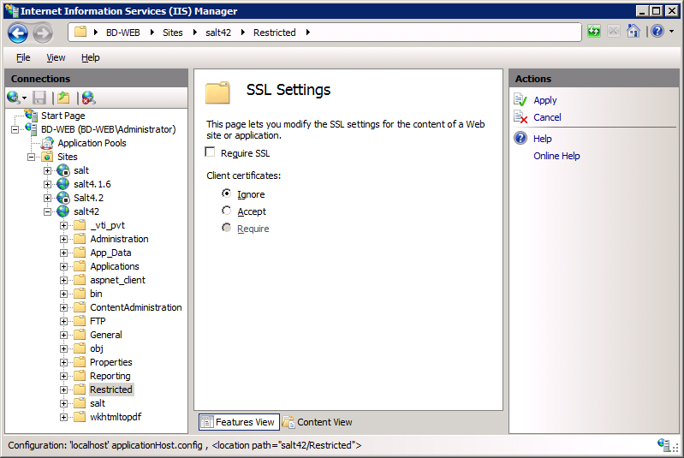
2. the "EnableSSL" key in the web.config file must be "false" : 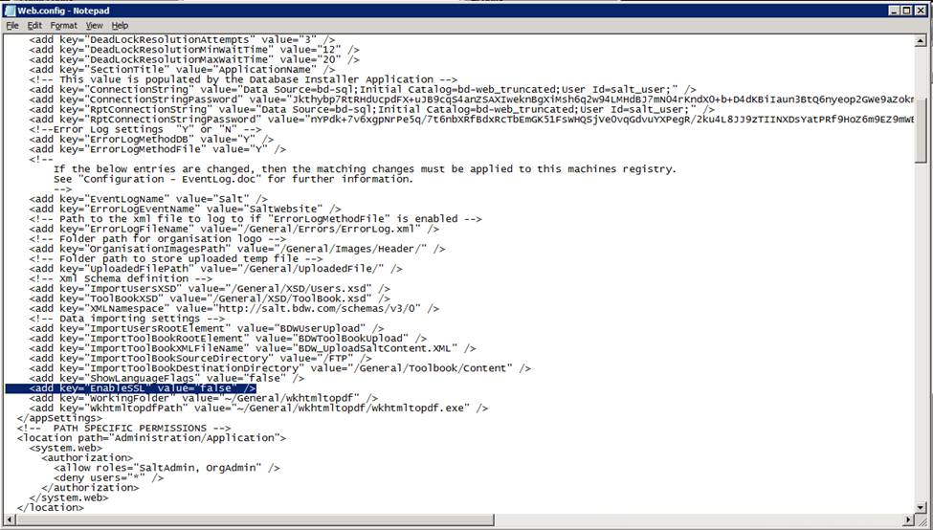
3. the value of "SSL" in tblAppConfig must be "false":